Tutorial 11 – Python + Selenium Navigation & Multi-page Workflow
Screenshot Report
Field | Details
Website / Tool | Automation Exercise
URL | https://automationexercise.com
Module | Navigation / Products / Cart
Student Task | Automate the navigation and multi-page workflow (open site, products, search, select, add to cart, open cart) with Python + Selenium and execute TC01-TC06.
Test Cases | Same TC IDs as the test case sheet: TC01 to TC06
Tester Name | Tester: Kothari Mann Jitendrakumar
Enrollment No | 2504030100433
Environment | Windows 10/11, Google Chrome (latest), internet connection

Test Case Execution

TC01 – Verify the website opens
TC ID | TC01
Test Case | Verify the website opens
Test Data | URL: https://automationexercise.com
Expected Result | Home page opens and the title contains 'Automation Exercise'
Actual Result | Home page opened; title contains 'Automation Exercise'
Status | PASS
Python Code Screenshot | 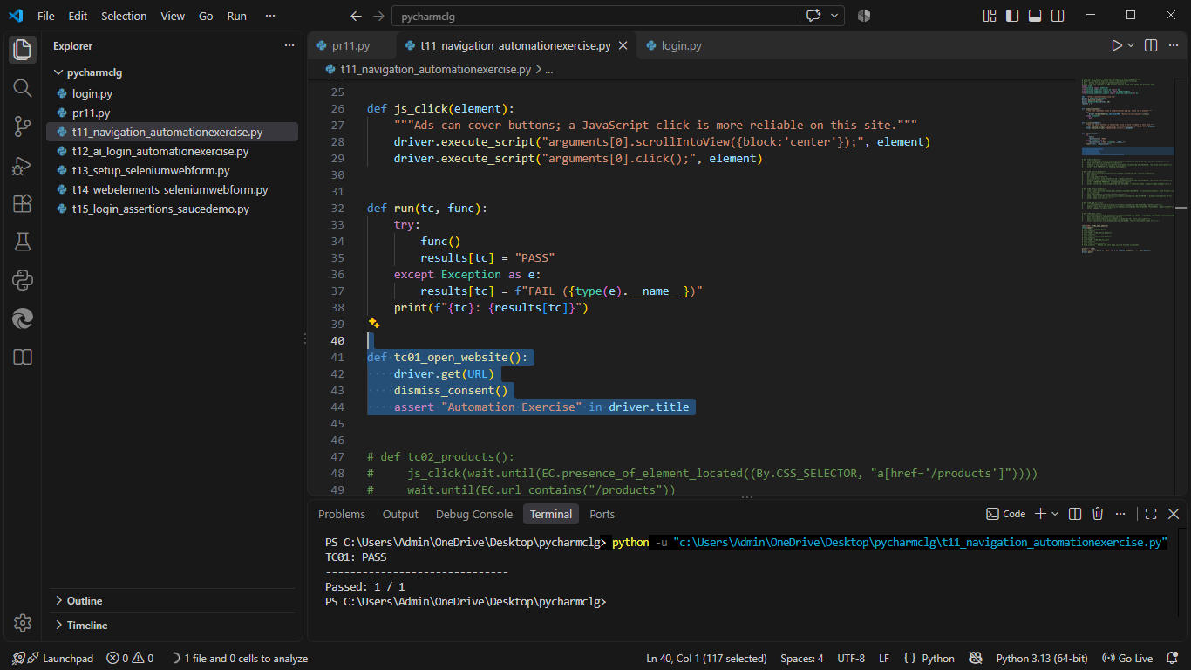
Browser Execution Screenshot | 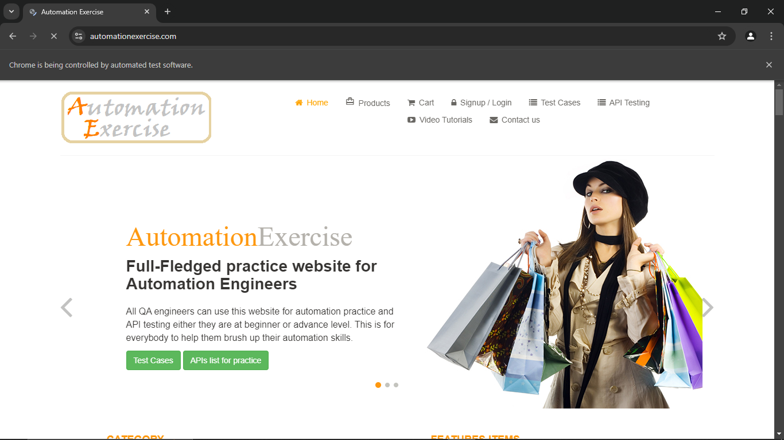
Defect ID | N/A

TC02 – Verify the Products page opens
TC ID | TC02
Test Case | Verify the Products page opens
Test Data | Link: Products
Expected Result | Products page opens with the 'ALL PRODUCTS' heading
Actual Result | 'ALL PRODUCTS' page displayed
Status | Pass
Python Code Screenshot | 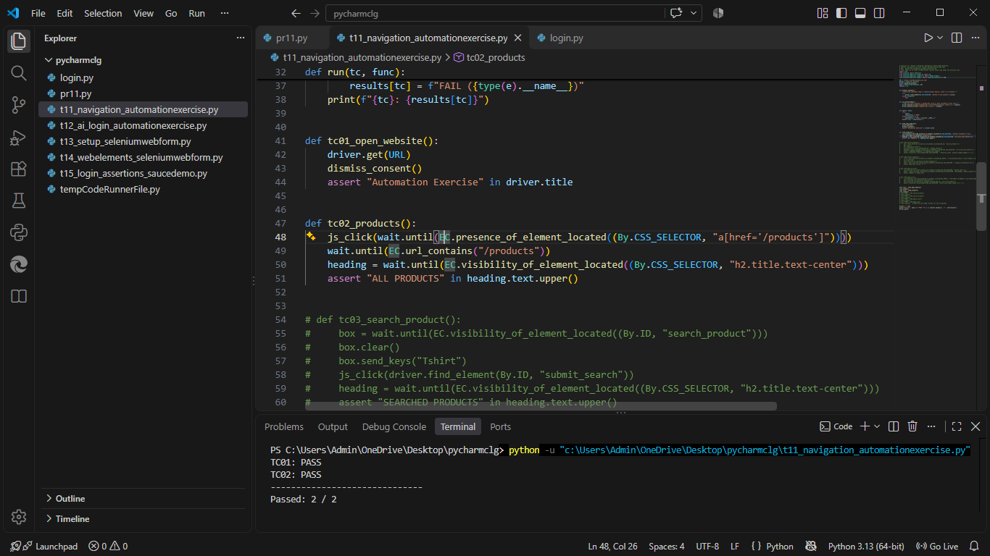
Browser Execution Screenshot | 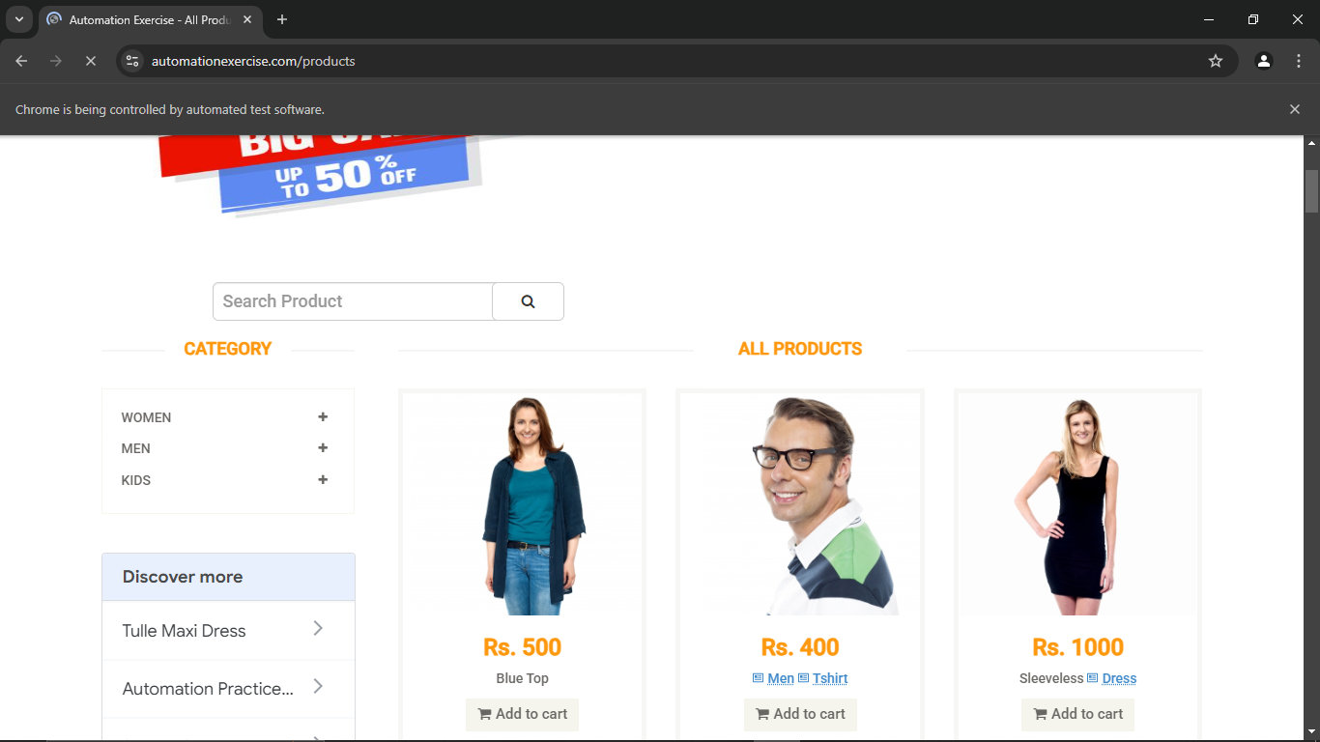
Defect ID | N/A

TC03 – Verify a product can be searched
TC ID | TC03
Test Case | Verify a product can be searched
Test Data | Search text: Tshirt
Expected Result | 'SEARCHED PRODUCTS' heading is shown with at least one matching product
Actual Result | 'SEARCHED PRODUCTS' shown with matching products
Status | PASS
Python Code Screenshot | 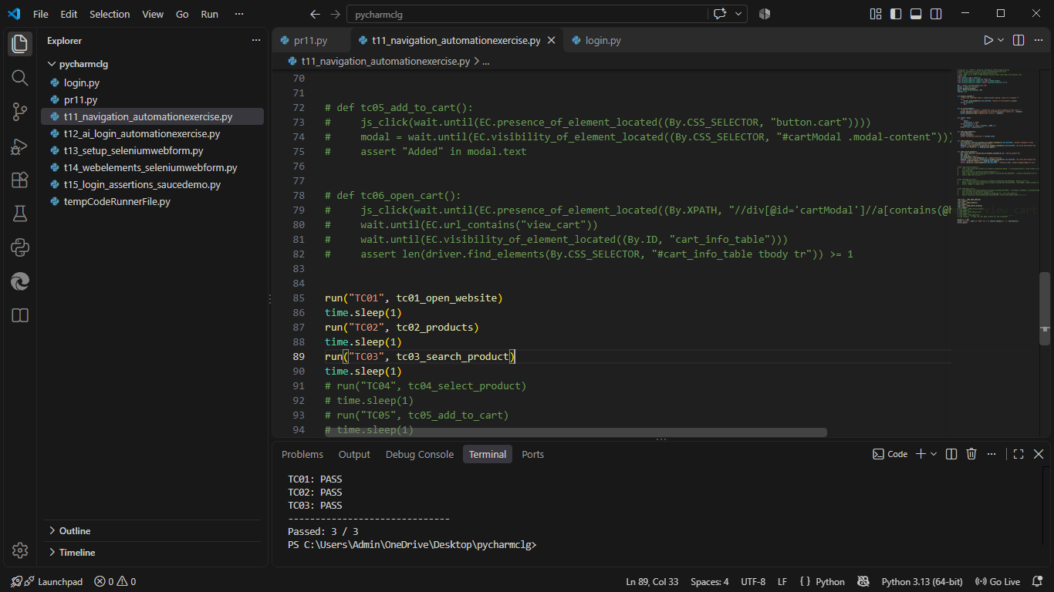
Browser Execution Screenshot | 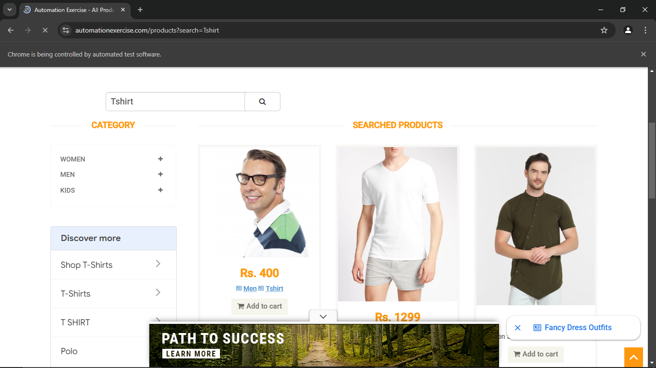.
Defect ID | N/A

TC04 – Verify a product can be selected
TC ID | TC04
Test Case | Verify a product can be selected
Test Data | First product of the search
Expected Result | Product details page opens and the product name is displayed
Actual Result | Product details page opened with product name
Status | PASS
Python Code Screenshot | 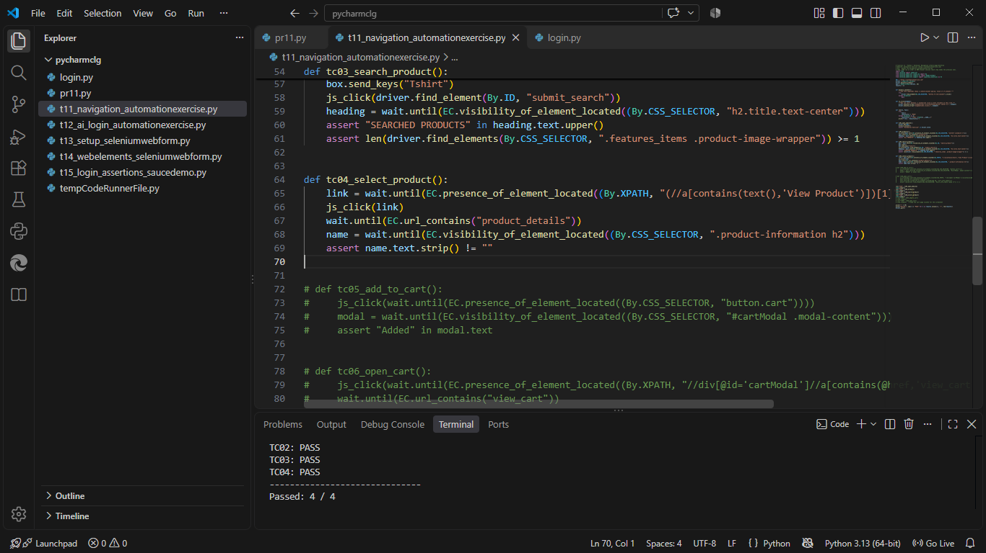
Browser Execution Screenshot | 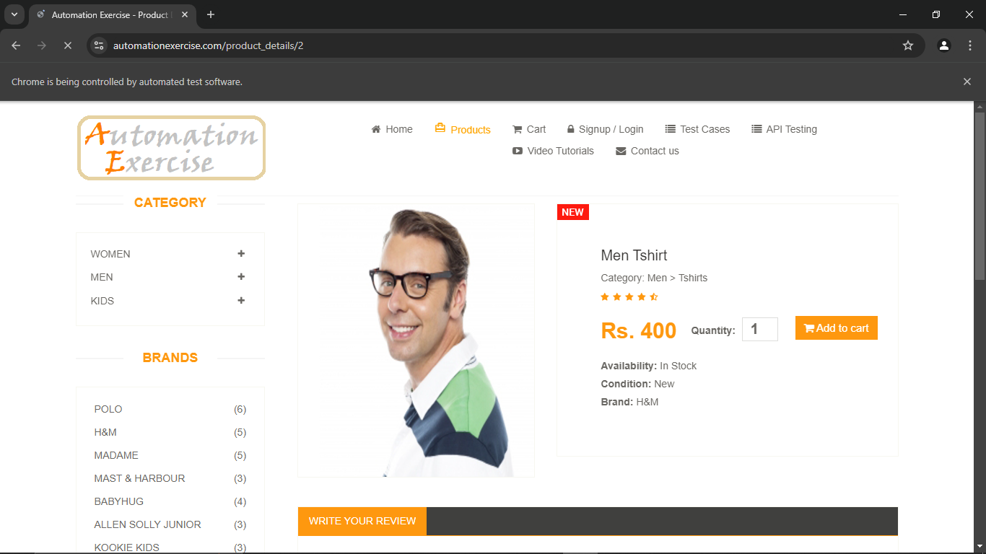
Defect ID | N/A

TC05 – Verify a product can be added to the cart
TC ID | TC05
Test Case | Verify a product can be added to the cart
Test Data | Quantity: 1
Expected Result | Pop-up 'Added! Your product has been added to cart.' is displayed
Actual Result | Pop-up 'Added!' displayed
Status | PASS
Python Code Screenshot | 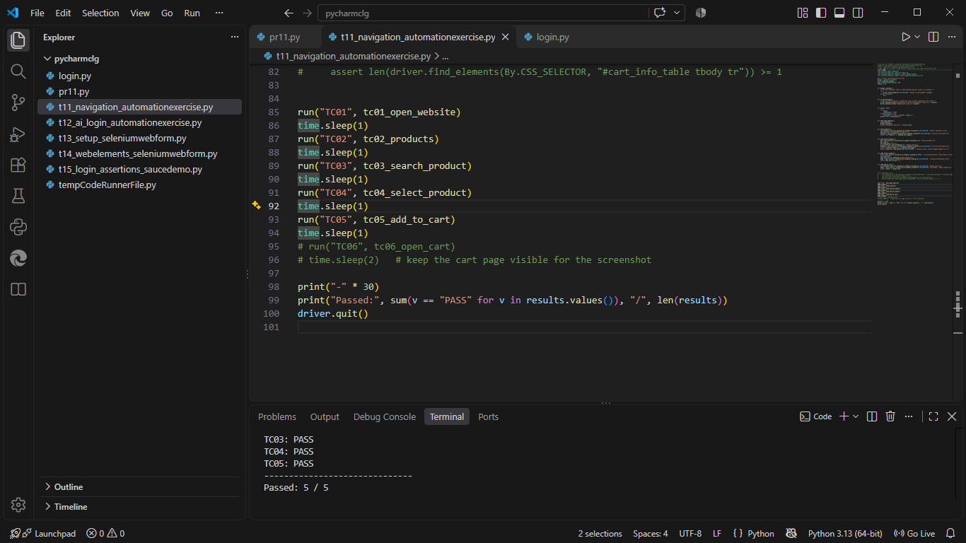
Browser Execution Screenshot | 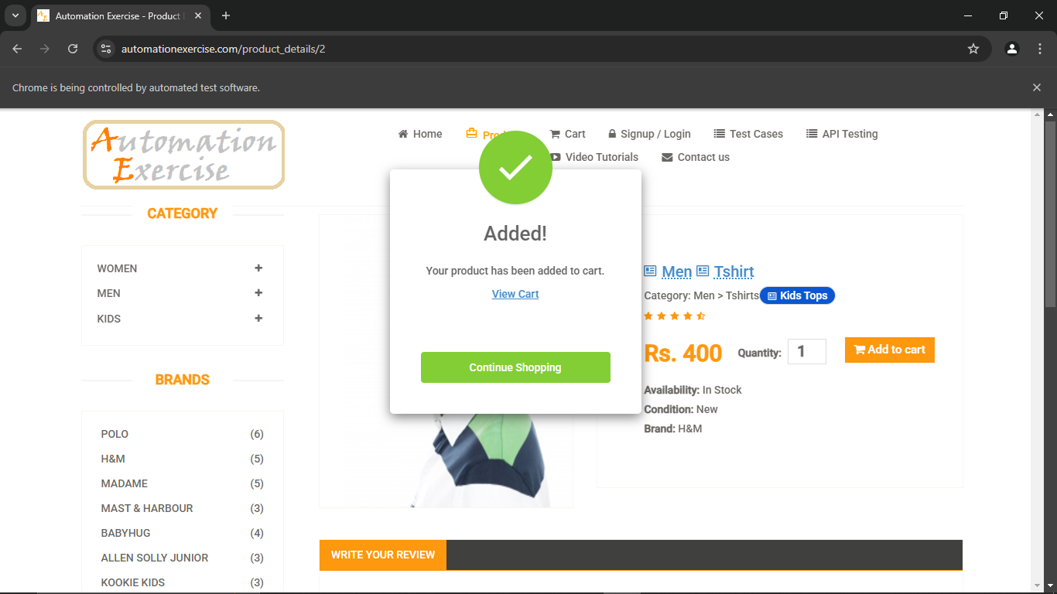
Defect ID | N/A

TC06 – Verify the cart can be opened
TC ID | TC06
Test Case | Verify the cart can be opened
Test Data | Link: View Cart
Expected Result | Cart page opens and shows the added product
Actual Result | Cart page opened with the product
Status | PASS
Python Code Screenshot | 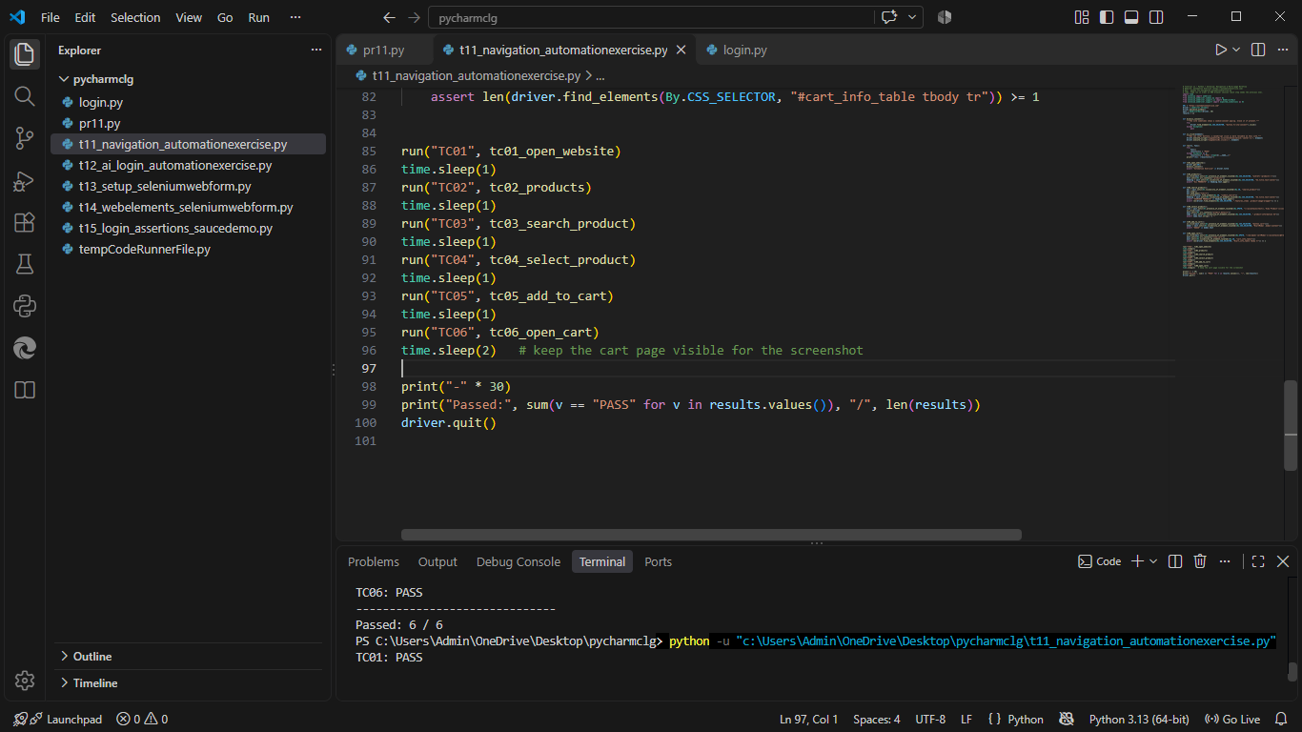
Browser Execution Screenshot | 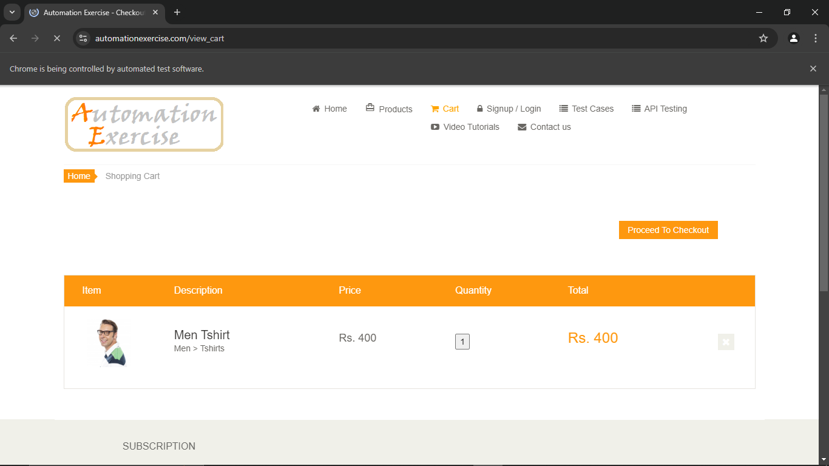
Defect ID | N/A

Locators used in t11_navigation_automationexercise.py
TC ID | Web Element | Locator Used in the Script
TC01 | Page title | driver.title
TC02 | Products link | By.CSS_SELECTOR, "a[href='/products']"
TC02 | Heading | By.CSS_SELECTOR, "h2.title.text-center"
TC03 | Search box | By.ID, "search_product"
TC03 | Search button | By.ID, "submit_search"
TC04 | View Product link | By.XPATH, "(//a[contains(text(),'View Product')])[1]"
TC05 | Add to cart button | By.CSS_SELECTOR, "button.cart"
TC05 | Confirmation pop-up | By.CSS_SELECTOR, "#cartModal .modal-content"
TC06 | View Cart link | By.XPATH, "//div[@id='cartModal']//a[contains(@href,'view_cart')]"
TC06 | Cart table | By.ID, "cart_info_table"

Test Execution Summary
Metric | Value
Total Test Cases | 6
Passed | 6
Failed | 0
Blocked | 0
Not executed yet (fill after running) | 0
Pass % | 100.0%

